Study of Battery Voltage Behavior under Loading and Charging Conditions using 3DFEM
Christopher R. Lashway, Student Member, IEEE, and Osama A. Mohammed, Fellow, IEEE
Energy Systems Research Laboratory, ECE Dept. Florida International University, Miami, FL USA
In this paper, a lithium ion cobalt polymer battery cell is modeled using 3D finite elements (3DFE) for the study of its performance under a wide range of operating scenarios. The electrochemistry is modeled and coupled to an electromagnetic model to forecast the cell voltage overpotential as a result of charging and discharging under 6 current densities. To study this phenomenon, light (C/10), medium (C/2), and high (1C) charging and discharging currents are imposed at the battery terminals and compared to experimental results. The electric field inside the electrodes and electrolyte are analyzed at each case highlighting regions where loss occurs. A magnetic field analysis depicts the total electrochemical generation of current densities inside the cell while identifying how the development of gradient currents occur, a mechanism which can shorten the lifespan of the battery. This work distinguishes where 3DFEA battery models can be useful in studying how lithium ion batteries will behave given a particular loading or charging profile before placing them in service.
Index Terms— Finite Element Analysis, Lithium ion batteries, Physics Based Modeling, State of Health.

I. Introduction
L
ithium ion batteries have become commonplace in our daily lives. Initially surfacing in the mobile phone and laptop industry, their high energy and power density makes them adequate for a number of applications. Unfortunately, the introduction of higher discharge currents, as in the emerging electric vehicle, introduces a voltage drop very different from legacy battery chemistries [1]. In the same light, high charging currents can push the terminal voltage to dangerous levels if not properly handled. To study these traits, a physics-based model (PBM) is needed which can provide a deep investigation into real-time battery performance and its long term state of health (SoH) [2]. A PBM provides a mechanism to not only accurately forecast the terminal voltage, but also track how electrochemical reactions impact the cell. This information is crucial in understanding how the design and package impacts operation while also providing a new mechanism to study how these behaviors can impact SoH.
Although SoH is primarily mapped to regulating the depth of discharge and temperature, the degradation of active materials is a complex process which must consider many variables that are not easily measured [3]. The combination of concentration overpotential, an electrochemical phenomenon caused by lithium ion concentration gradients developing at high currents and a variable conductivity of the electrolyte and electrode at different state of charge (SoC) levels result in gradient currents. Gradient currents at the electrodes cause nonlinear joule heating leading to uneven material stress which aids in degrading the cell SoH [4]. Through the development of a 3D Finite Element Model (FEM) of the battery, these phenomenon can be visualized and studied. In this work, a common lithium ion cobalt battery PBM is constructed using 3DFEM where an electric and magnetic field analysis is conducted under charging and discharging at C/10, C/2, and 1C current levels. An experimental analysis is made to verify the model while highlighting new operational features that can have a profound impact on the battery SoH which 3DFEM offers.
________________________________________________________________________________________________________________________
This work was partially supported by grants from the Office of Naval Research. The authors are with the Energy Systems Research Laboratory, Department of Electrical and Computer Engineering, Florida International University, Miami, FL 33174 (e-mail: mohammed@fiu.edu).

II. The Lithium Ion Battery
Lithium ion batteries exchange lithium ions using their electrolyte as a transfer layer between the positive and negative electrodes [2]. Many types exist and are characterized by differences in the metal (M) oxide used in their positive electrode (LixMO2), where the negative electrode is essentially a carbon graphite (LixC6) [5]. As the battery charges, lithium ions move from the positive to the negative electrode where the process is simply reversed during discharging. In this work, a lithium ion cobalt dioxide (LixCoO2) battery has been studied as it is not only a popular battery in mobile electronics, but has also been experimented with in transportation electrification because of its extremely high energy density. However, its safety and limited lifespan present a challenge in its utilization.
Traditional FEM of battery physics begins using a pseudo 2D representation only modeling the critical electrochemical processes along a line using minimum meshing points as shown in Fig. 1. These models only introduce the cell thickness $t_{P2D}$ and the active surface area $A_{P2D}$ to model operation neglecting dimensions of the package, plates, and current collectors. This formulation is computationally efficient and provides a superior improvement over legacy Randles circuit models during operation, but its simplification sacrifices a number of other details which provide insight into the internal electromagnetic losses and stresses across the structure of the battery [6]. An extension into 3DFEM provides a way to study new operational features of the battery while providing a mechanism to assess voltage losses across the electrolyte, magnetic field propagation, and generated gradient currents.

A. Mathematical Formulation
The basis of the nonlinear lithium ion 3DFEM formulation is broken into two major parts solving for both the electrochemical and electromagnetic components of the problem [8]. The insertion and extraction of lithium ions occur
 | 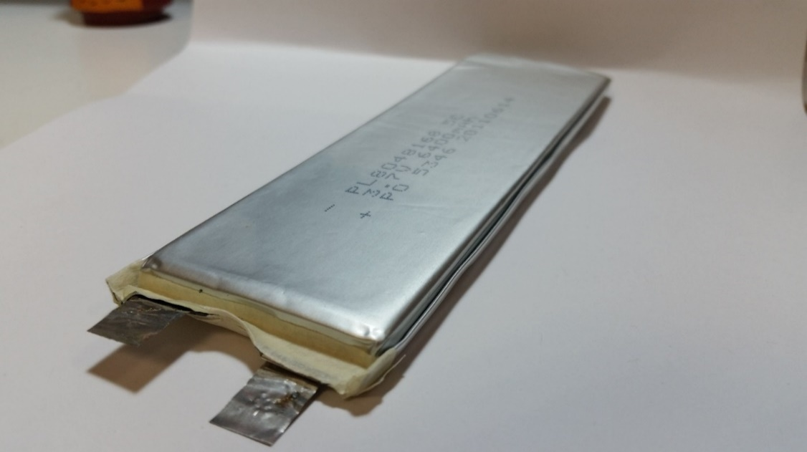
 | Fig. 2. PL8048168 Lithium Ion Cobalt Polymer Battery.
 | 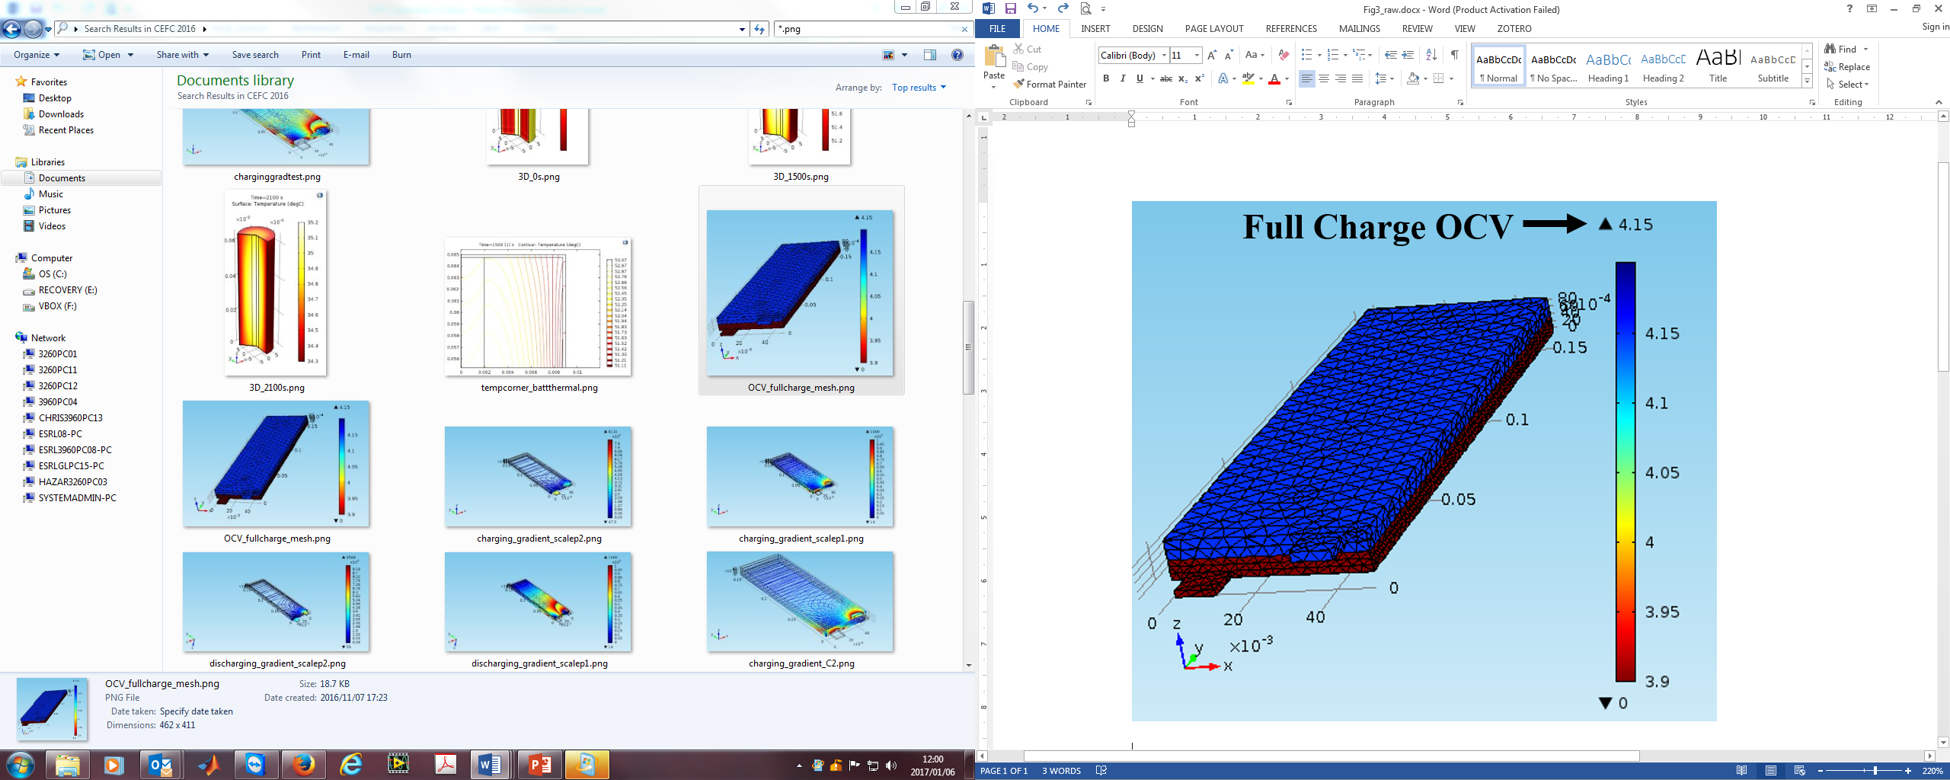
Fig. 1. Pseudo 2D FEM (P2D) to 3D FEM (3D) Representation. | Fig. 3. Electrostatic 3DFEM at Full Charge.

at the surface of each electrode and is represented by spherical particles of radius $r_{p}$ [2]. Molar flux of lithium at the particle surface is represented by:
$$R_{Li+}=-\sum{\frac{ν_{Li+}i_{loc}}{nF}\frac{A_{ν}r_{p}}{3ε_{s}}} (1)$$
where $ν_{Li+}$ is a stoichiometric coefficient, $i_{loc}$ is the localized current generated as a result of electrode kinetics, $n$ is the number of electrons involved in the reaction, $F$ is Faraday’s constant, $A_{ν}$ is the active surface area, and $ε_{s}$ is the electrode volume fraction.
Lithium diffuses $D_{s}$ to and from each surface altering the total concentration of lithium $c_{s}$ in the solid phase
$$\frac{∂c_{s}}{∂t}= ∇∙\left(-D_{s}∇c_{s}\right) (2)$$
subject to the following boundary conditions:
$$\left\{\begin{aligned} {\left.\frac{∂c_{s}}{∂r}=0\right|}_{r=0} \\ {\left.-D_{s}\frac{∂c_{s}}{∂r}=-R_{Li+}\right|}_{r=r_{p}}\end{aligned}=0 (3)\right.$$
The ratio of the present concentration of lithium ions in the electrodes $c_{s}$ versus their maximum storage capacity $c_{s,max}$ defines the $SoC$ of each electrode $s$.
$${SoC}_{s}= \frac{c_{s}}{c_{s,max}} (4)$$
As lithium ions move across the electrolyte, the mass of all reactants is conserved by the following relation:
$$ε_{l}\frac{∂c_{l}}{∂t}+∇∙\left(-D_{l}∇c_{l}\right)=R_{l}-\left(\frac{i_{tot}+Q_{l}}{F}\right)t_{+} (5)$$
where $ε_{l}$ is the electrolyte volume fraction, $c_{l}$ is the electrolyte concentration, $D_{l}$ is the electrolyte salt diffusivity, $t_{+}$ is the transport number for lithium ions, and $R_{l}$ is the reaction source term. A connection is made to the electromagnetics domain in (6) where the total generated cell current $i_{tot}$ and an arbitrary current $Q_{l}$ is constrained by the following relation:
$$∇∙\left(-σ_{l}∇ϕ_{l}+\frac{2σ_{l}RT}{F}\left(1+\frac{∂lnf}{∂{lnc}_{l}}\right)\left(1-t_{+}\right)∇lnc_{l}\right)=i_{tot}+Q_{l} (6)$$
where $σ_{l}$ and $ϕ_{l}$ represent the conductivity and electric potential of the electrolyte which vary based on $c_{l}$, R is the universal gas constant, T is the absolute temperature, and $f$ is an activity coefficient.
The lithium ion reaction at the electrode induces an exchange current density $i_{0}$ demonstrating how a primary current generated at the load is a result of the concentration of lithium at the electrodes:
$$i_{0}=F{\left(k_{c}\right)}^{α_{a}}{\left(k_{a}\right)}^{α_{c}}{\left(c_{s,max}-c_{s}\right)}^{α_{a}}{\left(c_{s}\right)}^{α_{c}}{\left(c_{l}\right)}^{α_{a}} (7)$$
where $k_{a},α_{a}$ and $k_{c},α_{c}$ represent the charge rate $k$ and transfer $α$ coefficients at the anode $a$ and cathode $c$, respectively. The Butler-Volmer expression describes how $i_{0}$ contributes to a localized current induced at the electrode surface which is dispersed in 3 dimensions:
$$i_{loc}(x,y,z,t)= i_{0}\left[e^{\frac{α_{a}η(x,y,z,t)F}{RT}}+e^{\frac{α_{c}η(x,y,z,t)F}{RT}}\right] (8)$$
where $α_{a}$and $α_{c}$ are the anodic and cathodic charge transfer coefficients, respectively, and $η$ is the activation overpotential revealing how the terminal voltage will drop or increase from its standard electric open circuit potential $E_{eq}$ under load or source.
$$η\left(x,y,z,t\right)=ϕ_{s}\left(x,y,z,t\right)-ϕ_{l}\left(x,y,z,t\right)-E_{eq} (9)$$
The electric field cannot propagate beyond the total width $w_{3D}$, length $l_{3D}$, or thickness $t_{3D}$ of the cell depicted in Fig. 1:
$$\left\{\begin{aligned}{\left.\frac{∂ϕ_{s}(x,y,z,t)}{∂x}\right|}_{x=0}={\left.\frac{∂ϕ_{s}\left(x,y,z,t\right)}{∂x}\right|}_{x=w_{3D}} \\ {\left.\frac{∂ϕ_{s}(x,y,z,t)}{∂y}\right|}_{y=0}={\left.\frac{∂ϕ_{s}\left(x,y,z,t\right)}{∂y}\right|}_{y=l_{3D}} \\ {\left.\frac{∂ϕ_{s}(x,y,z,t)}{∂z}\right|}_{z=0}={\left.\frac{∂ϕ_{s}\left(x,y,z,t\right)}{∂z}\right|}_{z=t_{3D}}\end{aligned}\right.=0 (10)$$
The resulting open circuit voltage of the cell is thus:
$$V_{cell}\left(t\right)=ϕ_{s,p}\left(l_{3D},y,z\right)-ϕ_{s,n}\left(0,y,z\right)-R_{f}I_{batt}\left(t\right) (11)$$
where $ϕ_{s,p}$ and $ϕ_{s,n}$ represent the electrode potentials at the positive $p$ and negative $n$ electrodes, respectively, and $R_{f}$ represents ohmic losses between the tabs and current collectors.

B. Finite Element Modeling
The PL8048168 lithium ion battery modeled in this study is shown in Fig. 2 which has a capacity of 6.4 Ah, though only 5.4 Ah is utilized to preserve its SoH [9]. The cell dimensions are 168.5 mm x 48.5 mm x 8.0 mm containing copper-based positive and aluminum-based negative current collectors measuring 10 mm x 10 mm x 0.1 mm. However, in order to provide a computationally efficient model, these dimensions were slightly altered to 150 mm x 50 mm x 10 mm to improve proportionality allowing for reduced 3D meshing elements. Since the cell has no onboard balancing circuitry, the length and width of each plate is consistent with its outer dimensions. The thickness of each electrode, electrolyte, and current collectors were estimated by normalizing the dimensions from a 2D model and are depicted in Fig. 1. These were then used to partition the cell thickness. Since the protective film is <0.1 mm, its offset could be neglected. The resulting mesh and the open circuit solution at full charge is shown in Fig. 3 where mesh elements were able to remain coarse reducing the degrees of freedom at the current collectors but are finer at boundaries where each electrode interfaces with the electrolyte.

III. Results and Discussion
To quantify the PBM, light, medium, and high loading and charging currents were applied where the results are shown in Table I. Currents were applied at the 10-hour (C/10), 2-hour (C/2), and 1-hour (1C) rates to both the pseudo 2D (P2D) and 3D models. All discharging currents were applied at full charge (100% SoC) while all charging currents were applied at full discharge (0% SoC).

A. Terminal Voltage and Analysis of Overpotential
The terminal voltage potential between the electrode plates and overpotential $η$ between measurements and each model as well as the error between the measured $η$ is shown in Table I. For discharging, light and heavy loading produces a strong correlation with less than a 3 mV variance, while medium loading introduces the highest error of 20.6 mV. In the charging case, a 5 mV variance is observed from the measured values for light and heavy currents, while the C/2 charging current drift is around 16 mV. The P2D follows a similar progression with its best accuracy at 1C and C/10, except with much greater error versus 3D. There are a number of potential causes for the error observed at C/2. First, the error could be a result of adjusting the electrode and electrolyte thicknesses to better align with the meshing scale. Adjusting these thicknesses, particularly the thickness of the electrolyte, varies the ohmic loss. Secondly, both the conductivity of the electrolyte $σ_{l}$ and electrodes $σ_{s}$ are functions of the electrolyte salt concentration $c_{l}$ and concentration of lithium ions $c_{s}$, respectively. Since the initial states vary greatly when starting from full charge or full discharge, these are driving factors.

B. Electric Field Analysis
An electric field analysis for the charging and discharging cases is shown in Fig. 4 and Fig. 5, respectively. The voltage potential distribution at the electrode plates is shown at the top revealing the departure from open circuit voltage (OCV) at each current level. For the charging case, as the current increases, the voltage at the electrodes increases consistent with Table I in a fairly linear fashion from 3.30 V (0% SoC OCV) to 3.49 V. In the discharging case, the voltage across the electrodes decreases dropping from 4.15 V (100% SoC OCV) to 3.95 V.
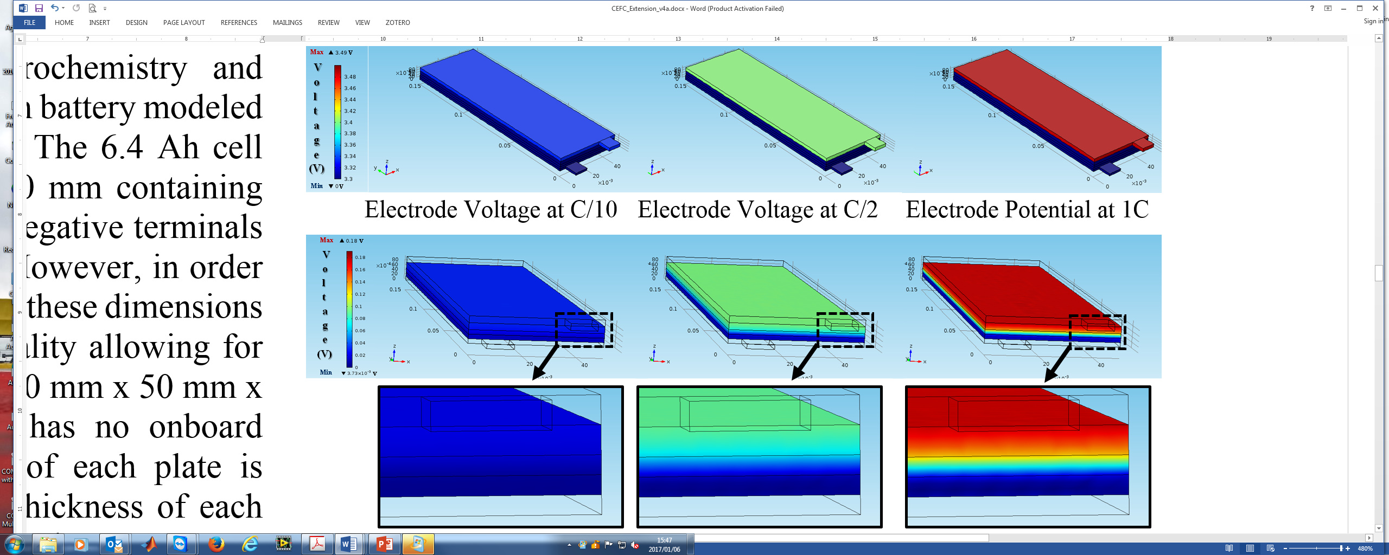
 | Electrode Voltage at +C/10 | Electrode Voltage at +C/2 | Electrode Voltage at +1C

 | Electrolyte Voltage at +C/10 | Electrolyte Voltage at +C/2 | Electrolyte Voltage at +1C
Fig. 4. Electric Potential at the Electrodes and Electrolyte under Charging.

TABLE I
Experimental, Pseudo 2DFEA, and 3DFEA Model Comparison
State | SOC  (%) | C  Rate | $$I_{batt}$$  (A) | Terminal Voltage |  |  | Overpotential $η$ (ΔV) |  |  | Error
 |  |  |  | Exp.  (V) | P2D  (V) | 3D  (V) | Exp.  (mV) | P2D  (mV) | 3D  (mV) | P2D  (mV) | 3D  (mV)
OCV | 100 | -- | -- | 4.149 | 4.142 | 4.149 | -- | -- | -- | -- | --
Discharge | 100 | -1C | -6.40 | 3.960 | 3.960 | 3.962 | -189.0 | -182.5 | -186.3 | +6.5 | +2.7
Discharge | 100 | -C/2 | -3.20 | 4.085 | 4.045 | 4.064 | -64.0 | -97.3 | -84.6 | -33.3 | -20.6
Discharge | 100 | -C/10 | -0.64 | 4.136 | 4.122 | 4.134 | -13.2 | -20.0 | -14.1 | -6.8 | -0.9
OCV | 0 | -- | -- | 3.300 | 3.318 | 3.315 | -- | -- | -- | -- | --
Charge | 0 | +1C | +6.40 | 3.477 | 3.512 | 3.488 | +177.0 | +194.0 | +172.5 | + 17.0 | -4.5
Charge | 0 | +C/2 | +3.20 | 3.370 | 3.427 | 3.402 | +70.0 | +109.3 | +86.2 | + 39.3 | +16.2
Charge | 0 | +C/10 | +0.64 | 3.313 | 3.342 | 3.333 | +13.0 | +23.8 | +17.3 | + 10.8 | +4.3

The current collectors reveal a potential distribution nearly constant across their surfaces. The electrode voltage distribution does not offer a great deal of insight in 3DFEM, however, this is not the case inside the electrolyte. The electric field distribution across the electrolyte is shown below in Fig. 4 for charging and Fig. 5 for discharging. For charging, C/10 results in a light voltage drop where the potential does not greatly vary. However, at C/2 and particularly 1C, there is significant variation. Close-ups demonstrate the progression in the electrolyte potential becoming highly nonlinear as it approaches high levels of current.

C. Magnetic Field Analysis and Gradient Currents
An extensive magnetic field analysis for the charging and discharging cases is shown in Fig. 6 and Fig. 7, respectively, highlighting a strength of the 3DFEM. Since the only measurable current is that which is delivered to the terminals, 3DFEM provides insight into the direction and magnitude of all generated electrochemical currents and location of the heavy losses. The top plots reveal the normalized (C-rate) current density normal across the cell and terminals under each of the 6 current levels. Current density vectors are superimposed to show current propagation across the cell as it is delivered to each electrode. Below, the analysis is extended viewing the current density normal as a contour plot from 0 to 1000 A/m² in 10 A/m² steps.
The charging cases are depicted in Fig. 6 where all current flows into the positive electrode dispersing across the cell structure. At C/10, the current density inside the electrodes is nearly equal to that which is delivered at the current collectors. This phenomenon is expected as at currents below the 5-hour rate (C/5)
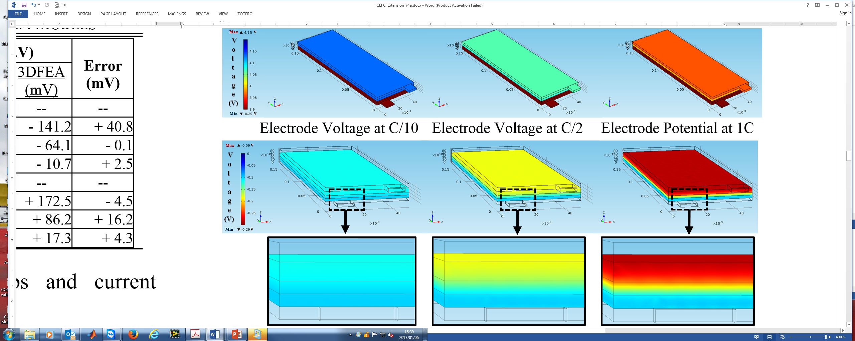
 | Electrode Voltage at -C/10 | Electrode Voltage at -C/2 | Electrode Voltage at -1C

 | Electrolyte Voltage at -C/10 | Electrolyte Voltage at -C/2 | Electrolyte Voltage at -1C
Fig.5. Electric Potential at the Electrodes and Electrolyte under Discharging.

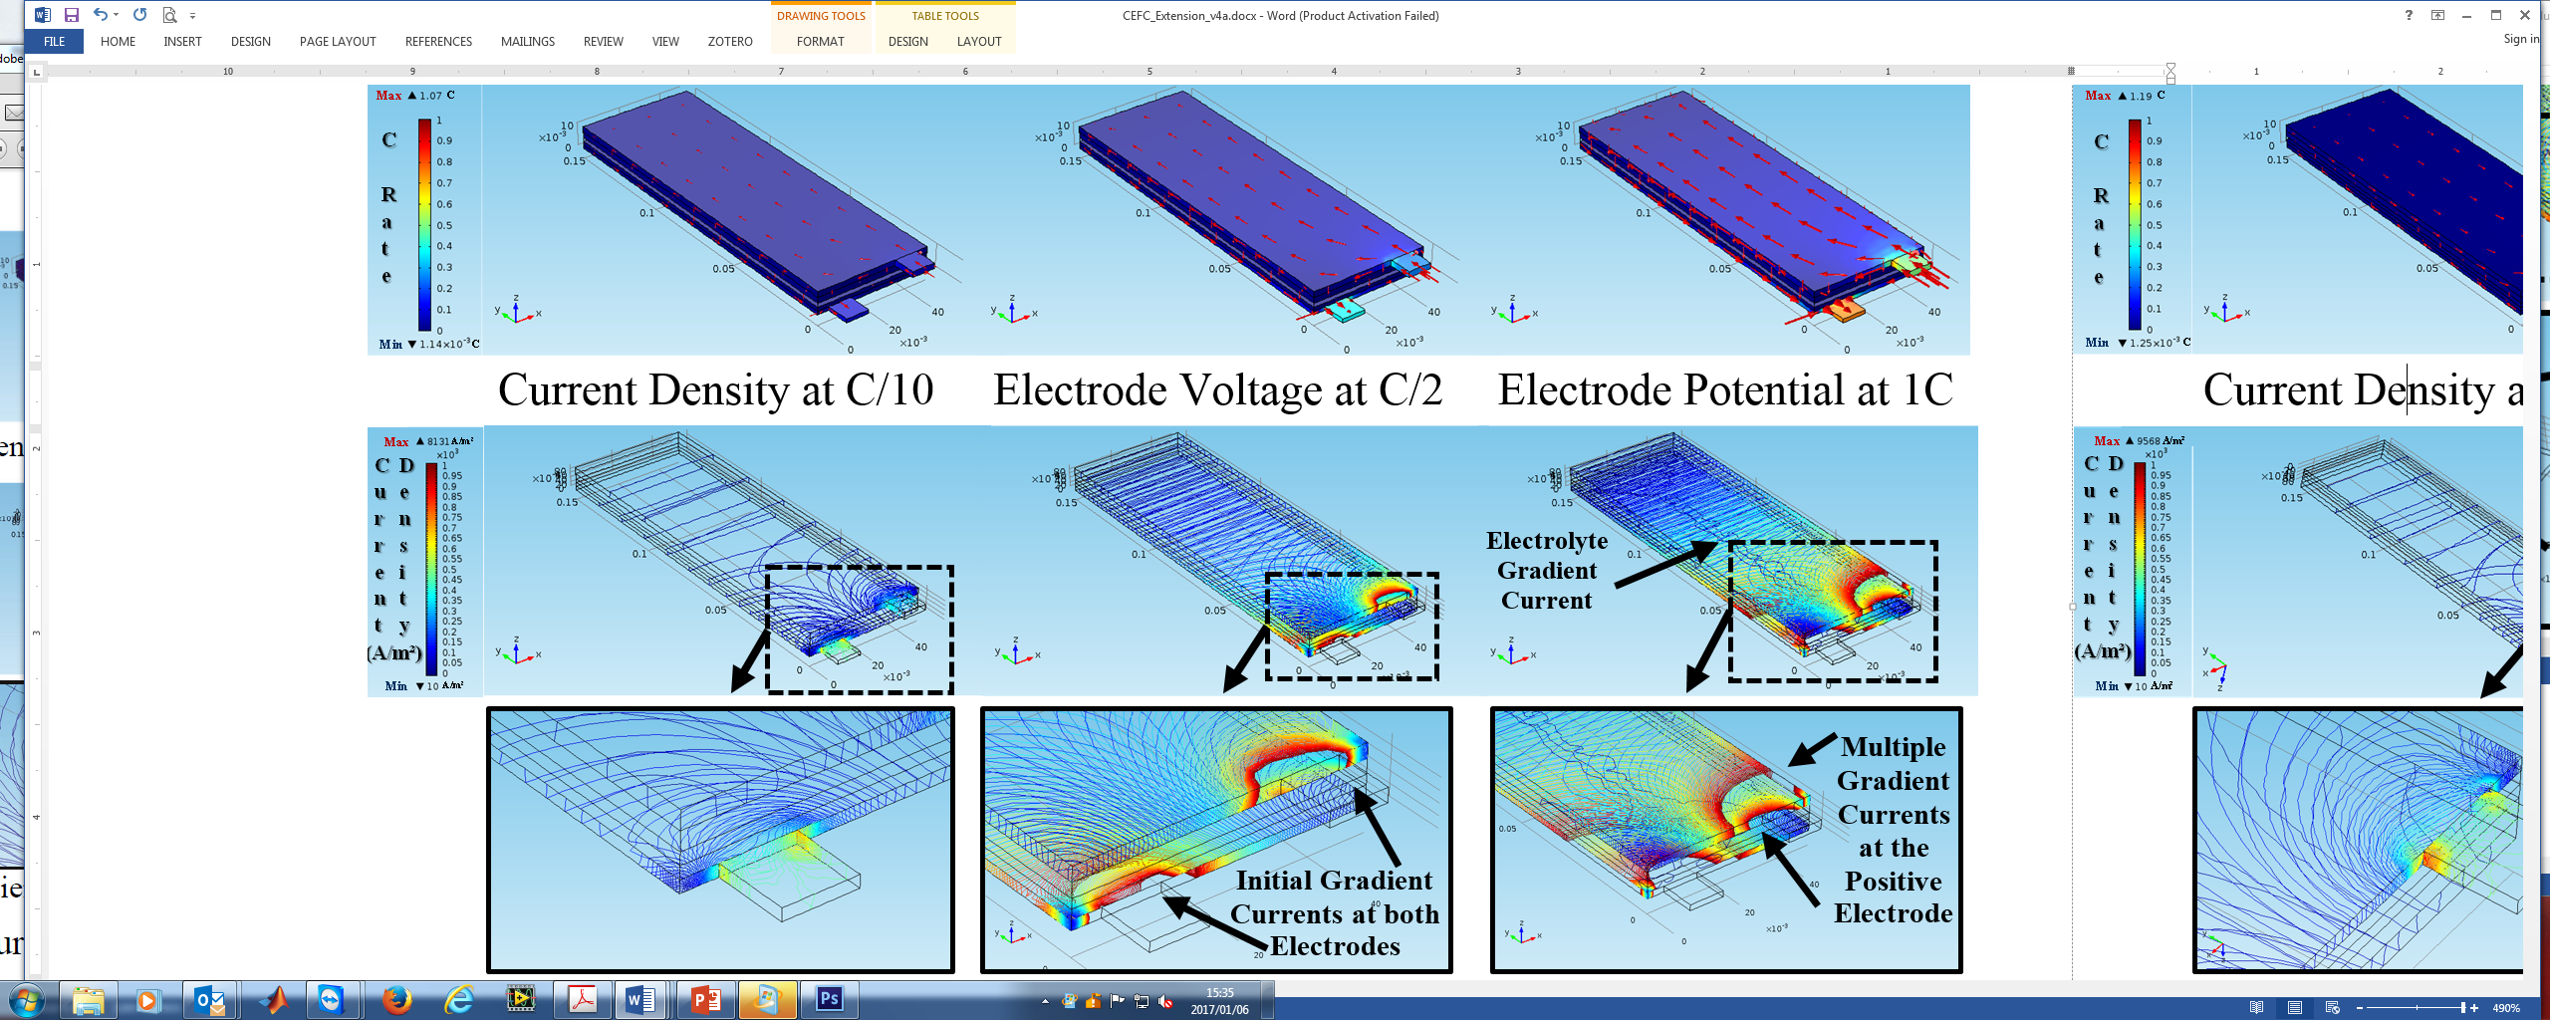
 | Current Density at +C/10 | Current Density at +C/2 | Current Density at +1C

 | Gradient Currents at +C/10 | Gradient Currents at +C/2 | Gradient Currents at +1C
Fig. 6. Current Density at the Electrodes and Electrolyte under Charging.

the energy input/output is close to the rated capacity as verified by the PL8048168 datasheet [9]. Below, the current density norm offers a different perspective. Although the cell current density is calm, some concentrations still form near the junctions where the contacts meet the current collectors.
At C/2, losses begin to increase and the effective C rate at each electrode shifts indicting parasitic losses occurring inside the cell. This phenomenon results in additional energy which will be needed to inject charge into the battery at C/2. Another contribution to these losses is caused by gradient currents which begin to surface near the electrode terminals. A close up identifies development at both electrodes. As charging approaches 1C, differences in the current density at each electrode intensifies. Looking at the top plot, although the cell is charged at 1C, the charging current required to overcome losses is 7% higher, or 1.07C. When analyzing the gradient currents, development occurs both at the electrodes and inside the electrolyte, though the magnitude inside the electrolyte is far less. A close-up reveals multiple concentrated currents forming on the electrodes as rings spreading from the positive electrode to nearly half the length of the cell structure. These features can easily go unnoticed without a reduced scale, as the maximum current density in charging is 8131 A/m².
For all discharging cases, current generated inside the cell is dispersed across the cell structure and delivered to the positive electrode. At C/10, the distribution is similar to that of the charging cases, where the normalized current density inside the electrodes is nearly equal to that which is delivered at the current collector contacts. Once again, the current density norm offers a different perspective, except concentrations at the junctions are slightly higher in magnitude with a peak near 1000 A/m² versus 700 A/m² in the charging case.
At C/2, the losses increase once again except the additional energy previously required from the charger is now required by the battery. The top plot reveals an imbalance between the current passing through each electrode. Below, the gradient currents are far worse than charging where multiple concentrated current density rings are already surfacing. As the load approaches 1C, the total electrochemical current density required to deliver energy is 19% higher, or 1.19C. This case results in the greatest difference between the terminals and is
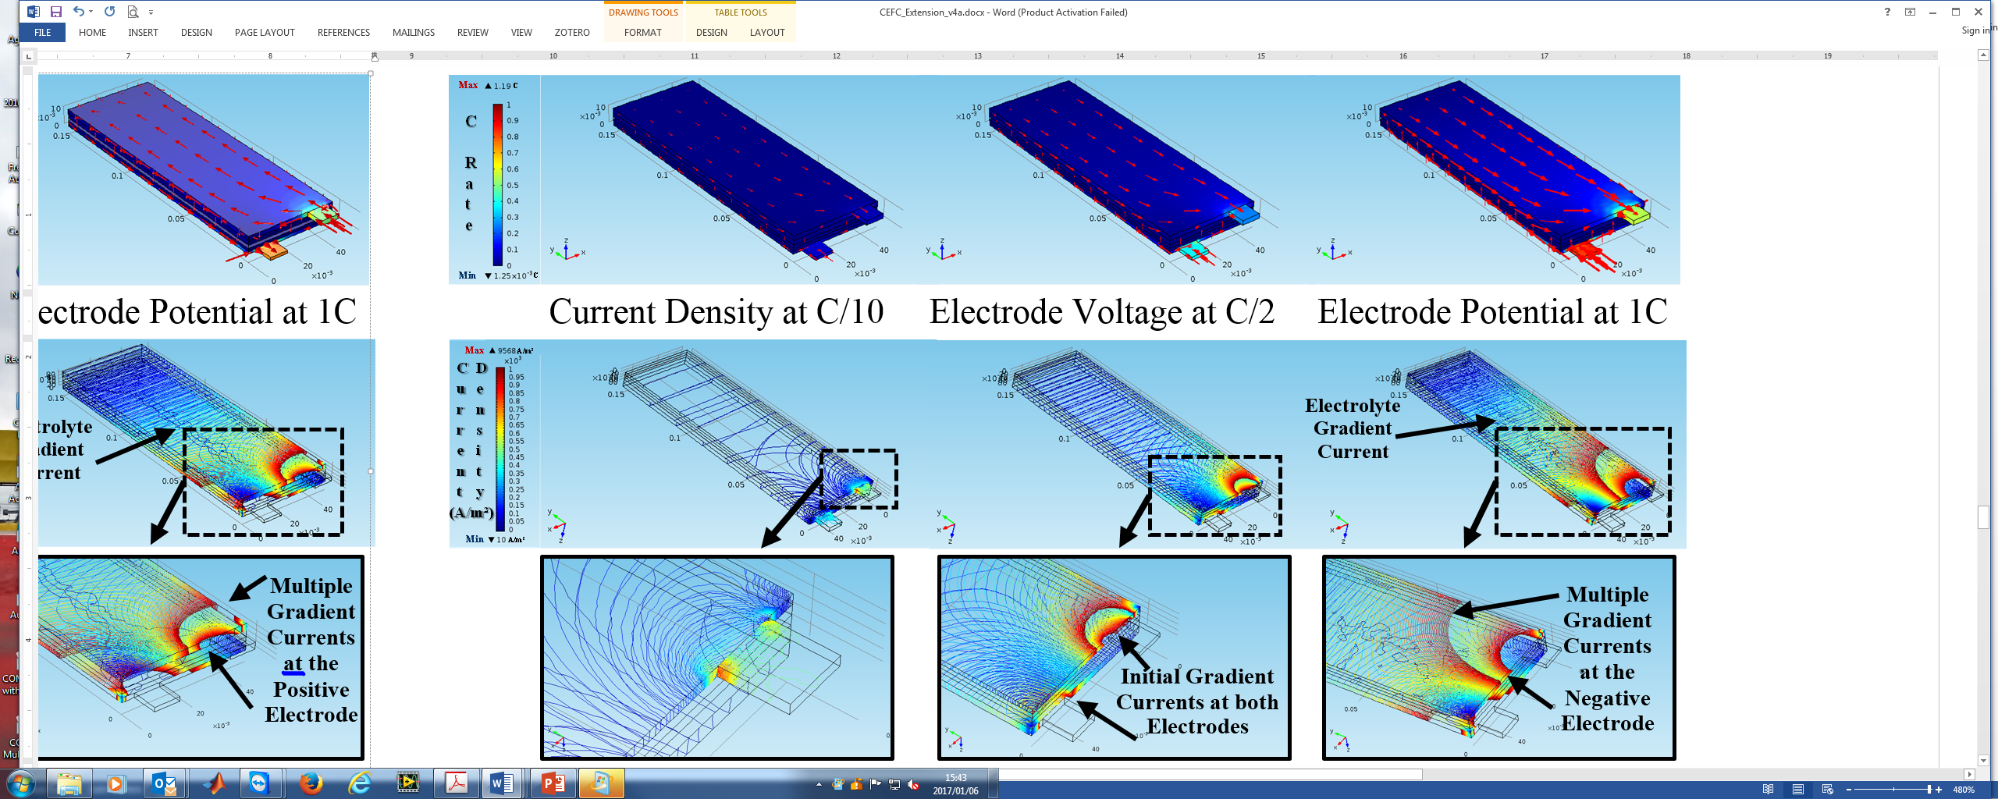
 | Current Density at -C/10 | Current Density at -C/2 | Current Density at -1C

 | Gradient Currents at -C/10 | Gradient Currents at -C/2 | Gradient Currents at -1C
Fig. 7. Current Density at the Electrodes and Electrolyte under Discharging.

further visualized by the gradient current generation which once again features both electrode and electrolyte gradients. The current density is high enough that multiple concentrated rings develop stretching beyond half the cell length.

IV. Conclusion
This study provided an extension of the common P2D lithium ion cobalt battery FEM into 3D to study operational characteristics difficult to obtain experimentally. Terminal voltages during both charging and discharging at C/10, C/2, and 1C currents were close to measured values. The results highlight new advantages 3DFEA can offer providing a mechanism to study the generation of undesired gradient currents across the cell when operating at high charging and discharging currents. A more accurate depiction of the voltage drop when moving from P2D to 3D is evident in the results in the form of gradient currents, contributing to uneven thermodynamic and material stress shortening the battery life.

References
[1] D. Linden, T. B. Reddy, “Lithium Ion Batteries” in Handbook of Batteries, 3rd ed. New York, NY: McGraw-Hill, 2002, ch, 35.
[2] R. Gu, P. Malysz, H. Yang, and A. Emadi, “On the Suitability of Electrochemical-Based Modeling for Lithium-ion Batteries,” IEEE Trans. on Transportation Electrification, vol. PP, no. 99, pp. 1–1, 2016.
[3] Juchuan Li, A. K. Dozier, Yunchao Li, Fuqian Yang, and Yang-Tse Cheng, “Crack Pattern Formation in Thin Film Lithium-Ion Battery Electrodes,” Journal of the Electrochemical Society, vol. 158, no. 6, pp. 689–94, Jun. 2011.
[4] J. Vetter et al., “Ageing mechanisms in lithium-ion batteries,” Journal of Power Sources, vol. 147, no. 1–2, pp. 269–281, Sep. 2005.
[5] “Types of Lithium-ion Batteries – Battery University.” [Online]. Available:http://batteryuniversity.com/learn/article/types_of_lithium_ion. [Accessed: 23-Nov-2016].
[6] R. Ahmed, M. E. Sayed, I. Arasaratnam, J. Tjong, and S. Habibi, “Reduced-Order Electrochemical Model Parameters Identification and SOC Estimation for Healthy and Aged Li-Ion Batteries Part I: Parameterization Model Development for Healthy Batteries,” IEEE J. Emerg. Sel. Topics Power Electron., vol. 2, no. 3, pp. 659–677, Sep. 2014.
[7] G. Perez, I. Gandiaga, M. Garmendia, J. F. Reynaud, and U. Viscarret, “Modelling of Li-ion batteries dynamics using impedance spectroscopy and pulse fitting: EVs application,” in Electric Vehicle Symposium and Exhibition (EVS27), 2013 World, 2013, pp. 1–9.
[8] COMSOL. "Theory for the Lithium-Ion Battery Interface", in Batteries & Fuel Cells User's Guide. Burlington, MA: COMSOL Inc., 2013, ch. 3, sec. 6, pp. 160-163.
[9] Battery Space, “Lithium Ion Polymer Rechargeable Battery,” Model PL8048168, Richmond, CA. Available Online: http://www.batteryspace.com/

